

School of Computer Science, UPES, Dehradun.

A

Lab 5

On Software Engineering

B.TECH. - V Semester

**Submitted to:**

Dr. Hitesh Kumar Sharma

**Submitted by:**

Name: Ishika Mehrotra

Batch: Devops B1

Sap Id: 500124411

Roll No.: R2142230281

**Lab Exercise 5- Generate and Use SSH Key with Git and GitHub**

**Objective:**  
To learn how to generate an SSH key, add it to GitHub, and use it to securely connect and push code without repeatedly entering a password.

**Step 1 – Check for Existing SSH Keys**

**Command:** ls -al ~/.ssh

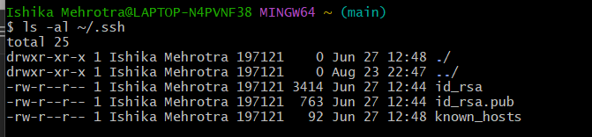

**Step 2 – Generate a New SSH Key**

**Command**: ssh-keygen -t rsa -b 4096 -C [your_email@example.com](mailto:your_email@example.com)

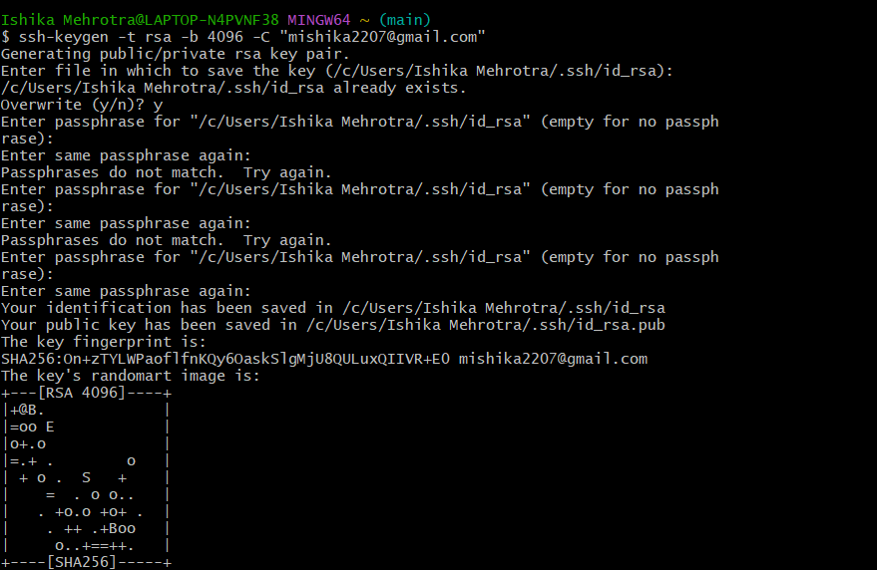

**Step 3 – Start the SSH Agent**

**Command:** eval "$(ssh-agent -s)"

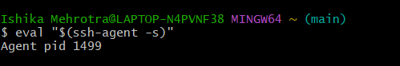

**Step 4 – Add SSH Key to the Agent**

**Command:** ssh-add ~/.ssh/id_rsa

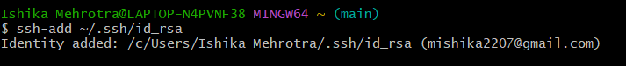

**Step 5 – Add SSH Key to GitHub**

**Command:** cat ~/.ssh/id_rsa.pub

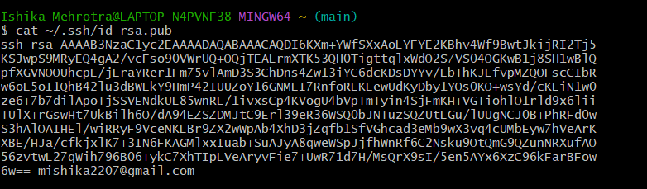

**Step 6 - Copy it to clipboard**

**Command**: cat ~/.ssh/id_rsa.pub | clip

Paste and save it on GitHub under Add SSH Key Option

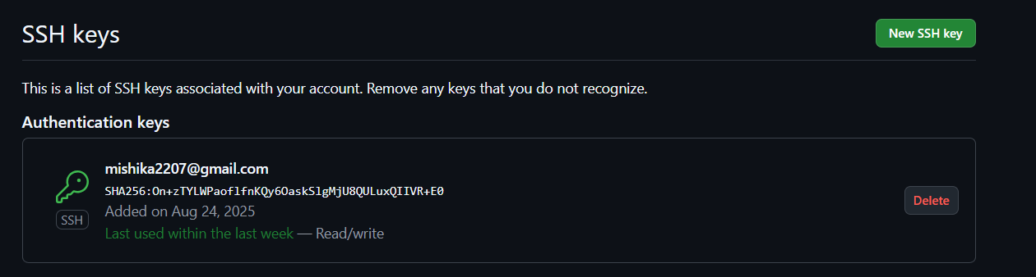

**Step 7 – Test SSH Connection**

**Command:** ssh -T git@github.com

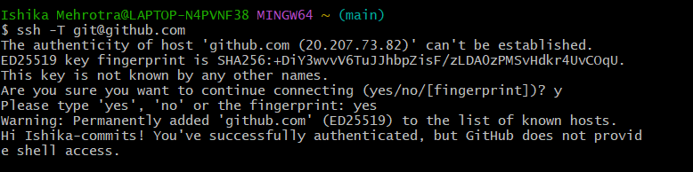

**Step 8– Use SSH to Clone a Repository**

**Command:** git clone [git@github.com:<username>/<repository>.git](mailto:git@github.com:%3cusername%3e/%3crepository%3e.git)

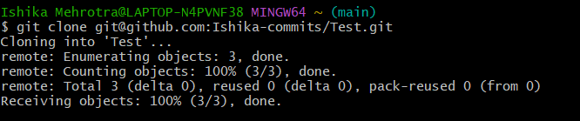

*Now you can pull and push without entering your username/password.*